<!DOCTYPE html>

<html lang="en">

<head>

    <meta charset="UTF-8">

    <meta name="viewport" content="width=device-width, initial-scale=1.0">

    <title>Form</title>

    <style>

 label{

    color: rgb(33, 197, 162);

 }

 body{

    background-color: rgb(255, 255, 255);

 }

 table{

    font-size:large;

 }

 h1{

    background-color: darkgrey;

 }

 .submit{

    text-align: right;

    font-size: 32px;

     background-color: darkgrey;

     height: 43px;

     align-content: center;

 }

 #create{

    width: 150px;

    font-size: 26px;

    background-color: rgb(4, 198, 156);

    color:white;

 }

</style>

</head>

<body>

    <h1 align="center">Create Account</h1>

<table>

<tr> <td> <label for="name" >First Name</label> <br>

<input type="text"  placeholder="Enter your name"> <br> </td>

<td> <label for="name" >Last Name</label> <br>

<input type="text" placeholder="Enter your last name"> <br> </td> </tr>

<tr> <td> <label for="email" >Email</label> <br>

<input type="email" placeholder="abc@example.com"> <br> </td> </tr>

<tr> <td> <label for="password" >Password</label> <br>

<input type="password" placeholder="Enter password"> <br> </td>

<td> <label for="password">Confirm Password</label> <br>

<input type="password" placeholder="Repeat password"> <br> </td> </tr>

<tr> <td> <label for="gender" >Gender</label><br>

    <input type="radio" name="gender">

    <label for="male" >Male</label>

    <input type="radio" name="gender">

    <label for="female" >Female</label>

    <input type="radio" name="gender">

    <label for="other" >Other</label><br> </td>

<td> <label for="hobbies" >hobbies</label><br>

        <input type="checkbox">

        <label for="music">Music</label>

        <input type="checkbox">

<label for="read">read</label>

        <input type="checkbox">

        <label for="travel">Travel</label>

        <input type="checkbox">

        <label for="cook">Cook</label>  </td> </tr>

<tr> <td> <label for="source" >Source of income</label><br>

  <select name="source">

          <option value="Employed">Employed</option>

          <option value="Student">Student</option>

          <option value="Assistant">Assistant</option>

          <option value="Unemployed">Unemployed</option>

        </select> </td>

    <td> <label for="income" >Income</label><br>

        <input type="range" value="20" min="20" max="100"

oninput="this.nextElementSibling.value = this.value">

        <output>20</output>k </td> </tr>

<tr>     <td> <label for="picture">Upload Profile Picture</label><br>

        <input type="file" > </td>

    <td> <Label for="age" >Age</Label><br>

        <input type="number"> </td> </tr>

</table>

<label for="bio">Bio</label><br>

        <input type="text" style="width: 420px; height: 70px;"><br><br>

<div class="submit">

    <input id="create" type="submit" value="Create">

</div>

</body>

</html>

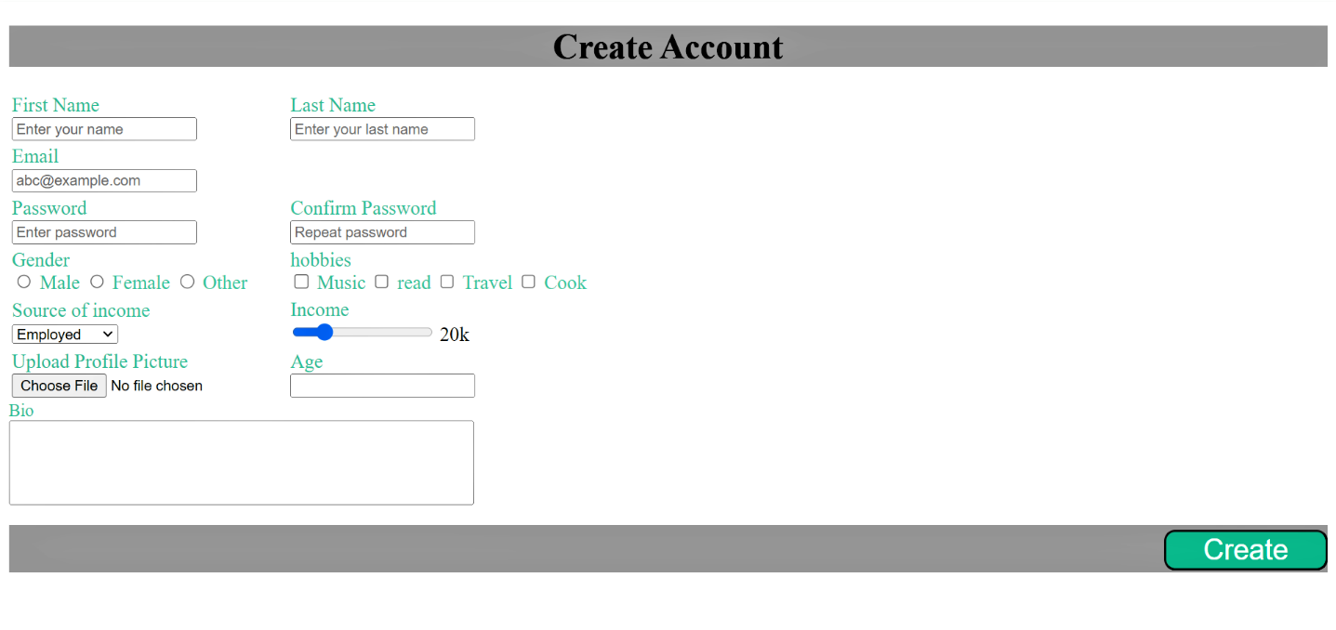**OUTPUT**